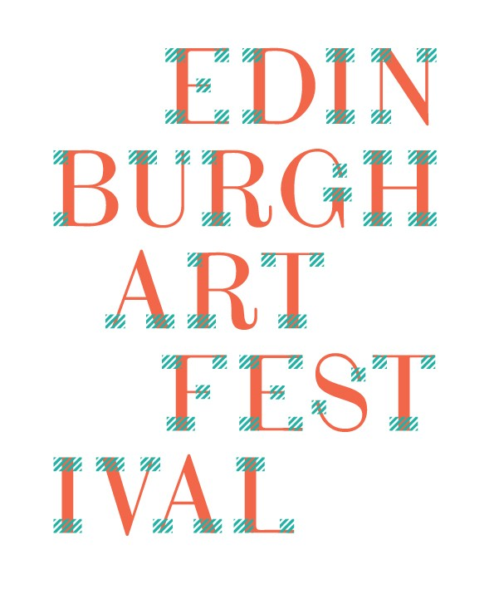

Call Out: Edinburgh Art Festival Volunteers 2017

Deadline for application: Friday 9 June, 5pm

Recruitment days: Friday 16 June

Edinburgh Art Festival is issuing our annual call for volunteers for the 2017 festival, running from 27 July to 27 August. Volunteers play a key role in the festival, hosting visitors from near and far to the UK’s largest annual festival of visual arts. This is an exciting opportunity for you to develop your skills, meet like-minded individuals, experience cutting edge visual art and have a fun festival experience. We are seeking enthusiastic, friendly and engaged volunteers to join our team and provide an outstanding visitor experience. As part of the Edinburgh Art Festival team of volunteers you will gain great work experience and discover the festival from a whole new perspective.

Founded in 2004, Edinburgh Art Festival is the UK's largest annual festival of visual art. We bring together the capital’s leading galleries, museums and artist-run spaces, alongside new public art commissions by established and emerging artists as well as an innovative programme of interconnected events. Volunteers work with us specifically in the Festival Kiosk and across our public commissions, as well as assisting with stewarding events and key activities such as artists' talks and the wider events programme. There will be opportunities for those who are interested in the particular area of events to register their interest in being considered for paid opportunities to support the evening events programme.

At each venue you will be the first point of contact for visitors so it is important that volunteers are able to communicate comfortably with visitors, demonstrate an enthusiasm for visual arts and provide accurate information. Volunteers work with the Volunteer Coordinator, Kiosk Coordinator and Festival Assistants to ensure the welcome and safety of visitors at each venue, the security of artworks and to provide information where required about the artworks and about the festival in general. Volunteers also work within the Kiosk, our main information point for the festival, and assist with related festival activity, display and promotion of festival merchandise and events information, also with the Children and Families engagement programme, where required.

Edinburgh Art Festival volunteers are based at venues throughout the city weekdays and weekends. The daily start and finish times are 9.45am and 6.15pm respectively, and volunteers can commit to either full day or half day sessions. A flexible approach is required as locations may alternate during each volunteering session.

As part of the volunteer team you will be provided with training and induction, tours of venues, a Volunteers handbook, a festival branded t-shirt, and invitations to special events and exhibitions when possible. While this is an unpaid opportunity, we do offer travel and subsistence expenses per day up to a value of £12.50 (on production of documentation/receipts).

This is an unpaid opportunity classified as voluntary work. For more information regarding volunteering at Edinburgh Art Festival please see our Volunteer Policy (available on the Volunteer page on our website).

Apply
To apply for this opportunity, please complete the application form below and equal opportunities monitoring form, and email them to:
info@edinburghartfestival.com with e-mail subject ‘Volunteer Application’ no later than Thursday 8 June 2017 by 5pm.

Recruitment
All accepted applicants must be able to attend one of the Volunteer Recruitment sessions (AM or PM) to be held on Friday 16 June.

Training
All volunteers will be required to attend a group training session prior to the festival launch (details tbc).

*Please note due to the nature of the work in public spaces across the city, we are unable to accept volunteers under the age of 16yrs.

EDINBURGH ART FESTIVAL VOLUNTEER Application Form

All information received will be treated according to the Data Protection Act 1998, and will not be shared with any third parties.

Personal Information:
Name:
Email:
Address:
Postcode:
Telephone:

Why would you like to volunteer with us?
(300 words)

Please tell us about any other relevant experience of volunteering, working with the public and/or contemporary art?
(300 words)

Have you ever been a volunteer before? – please give details.
(200 words)

Availability:
Monday Tuesday Wednesday Thursday
Friday Saturday Sunday

If there are any specific dates or times on which you will be unavailable please provide details:
I can confirm I am over 16 years old
Please note due to the nature of the work in public spaces across the city, we are unable to accept volunteers under the age of 16yrs.

How did you hear about volunteering for us?
EAF Website Social Media Creative Scotland
Other Website Web search
University Network - please specify
Other – please specify

