Edinburgh Art Festival invites
you to get creative at home

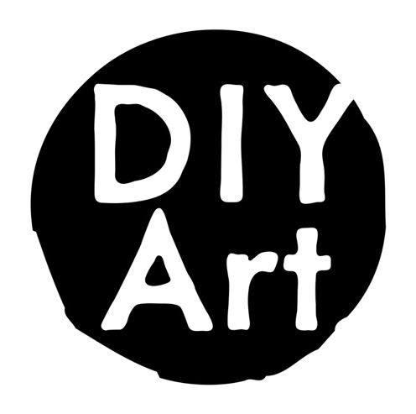
Drawing: The space in between
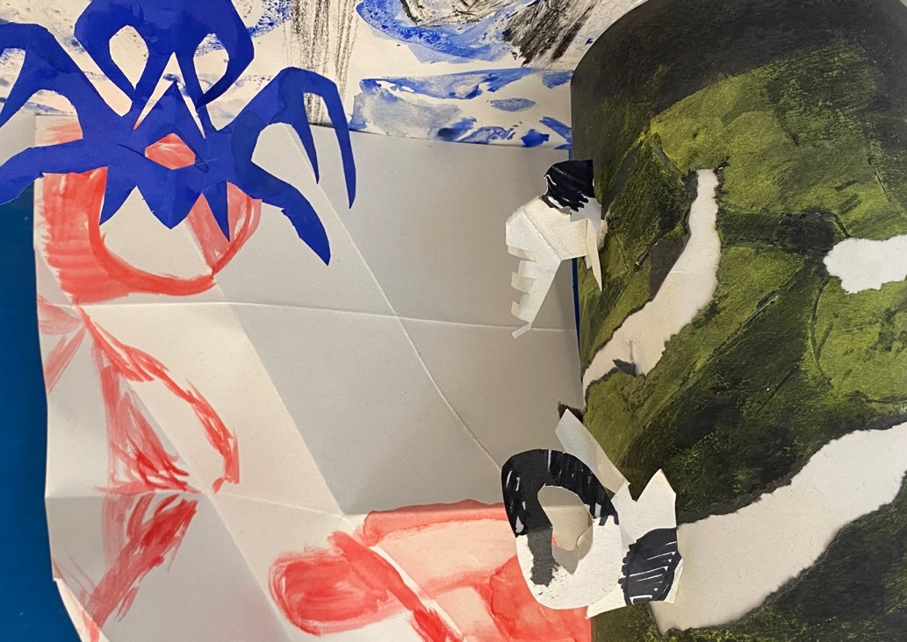
Made with and for people with visual impairment
Home Creativity Kit by Louise K Fraser devised in consultation with Kasia Jakimczuk, Anne Dignan,
Alan McIntyre, Alex Maxtone-Graham and Steve Oliver

Introduction

Drawing: The space in between is the second home creativity kit in the DIY Art series, made with and for people with visual impairments. The kit was devised through consultation workshops led by artist Louise K Fraser with visually impaired artists Kasia Jakimczuk, Anne Dignan, Alan McIntyre, Alex Maxtone-Graham and Steve Oliver. It is designed for everyone to explore drawing and mark making, using positive and negative space in new ways. In the kit you will explore a set of drawing materials, find different ways to think about space on a page and find prompts to decide where you would like your skills to go next.

The kit is divided into 3 sections – Explore, Develop and Expand – and open to all levels of experience. You will build a set of skills and are able to dip in and out of the pack. Each section of the kit takes about 30 minutes to complete, or longer if you are enjoying the process.

The process

The group met over several sessions, using the first kit as a jumping off point, to explore a wide range of materials and process in a workshop co-delivered by Louise and Kasia. From this, a set of relevant materials and processes were identified and explored further to develop this second kit.

The next stage involved the artists and graphic designer James Brook, discussing layout, typeface, and image description placement alongside exploring materials, techniques and assemblages. The final step in the process included working with the artists to refine the materials layout for the post-able kit.

The kit is designed to be used by visually impaired people with no previous art making experience and the structure of this project is an ever-evolving model. We are always interested to hear from those who would like to be involved with the creation of the next edition and welcome feedback.

If you would like more information or to suggest feedback, please contact: learning@edinburghartfestival.com

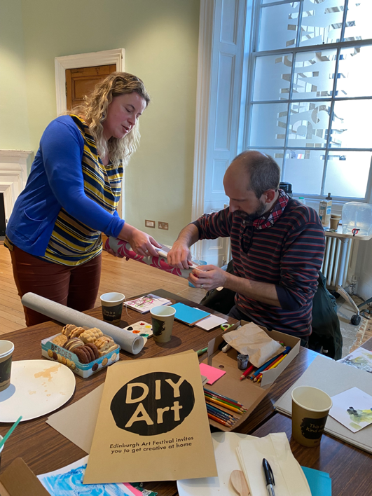
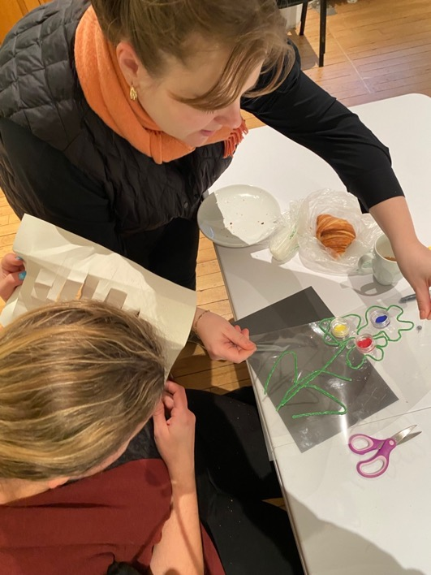

Image 1, front cover
Image description: Photograph of artwork created by artists Kasia Jakimczuk and Steve Oliver at a consultation workshop.

Image 2, left
Image description: Artists Kasia and Alan McIntyre exploring the texture of paper in a consultation workshop.

Image 3, right
Image description: Artist Kasia and community engagement manager Holly Yeoman working together in a consultation workshop, looking at one of Kasia's creations – a flower shape formed from waxed string on
a clear plastic sheet.
Materials to use with your DIY Art home creativity kit

Drawing material could be
1. Pencil
2. Coloured pencils
3. Black marker pen
4. Coloured pens
5. Crayons

Any other drawing materials that like you like to use.

Painting material
6. Paint brush
7. Paint pallet
8. Materials like spices from the kitchen instead of paint just add water

Any other painting materials that like you like to use.

A collection of different papers
9. Collect any other papers that like to use these could be thicker card or art paper or why not look in the recycling bin for paper?

You also need to collect
10. Scissors
11. Drawing pin
12. Small roll of tape
13. Glue stick

Other items you might have at home and like to use
- Stickers or sticky backed foam shapes
- Waxed string sometimes called Wikki sticks or Benderoos
- Blu tack
- A collection of everyday objects with simple shapes to draw around

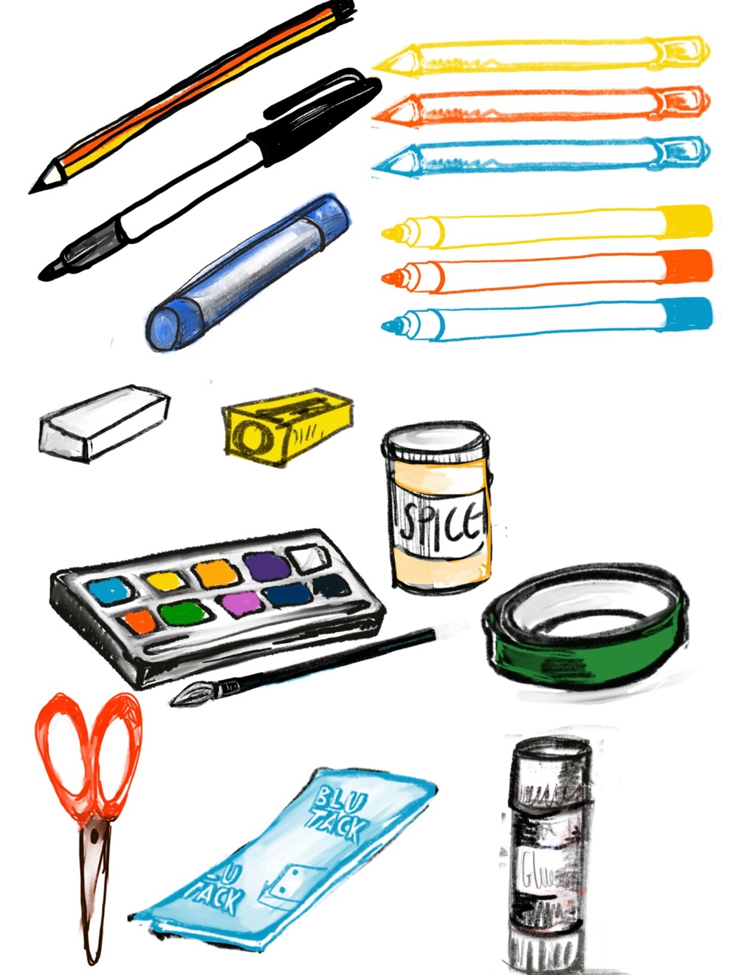
Image 4
Image description: A colour illustration featuring a selection of materials to use with your DIY Art home creativity kit.
Explore
Drawing Materials

You need: a selection of drawing materials and paper

First

Take a piece of paper and test out the drawing materials you have collected. Try drawing the outline of different shapes.




triangle square circle splodge

You could draw around everyday objects you find around you.

If you would like to create raised outline shapes use waxed string, Blu Tack or tape.

Next
Make some decision on the materials you have gathered.

What drawing materials did you enjoy using? For example, did you enjoy them because of the way they move when drawing, the mark they make on the page or the way they smell.

Last
We are going to start to explore the concept of positive and negative space.

- Go back to the outline shapes you made first. Take a drawing material you enjoyed using and fill a shape. You have now created a positive shape.

- Now draw around another outline shape, you made earlier. Fill in around the outside shape leaving the inside shape blank. You have now created a negative shape.

Image 5
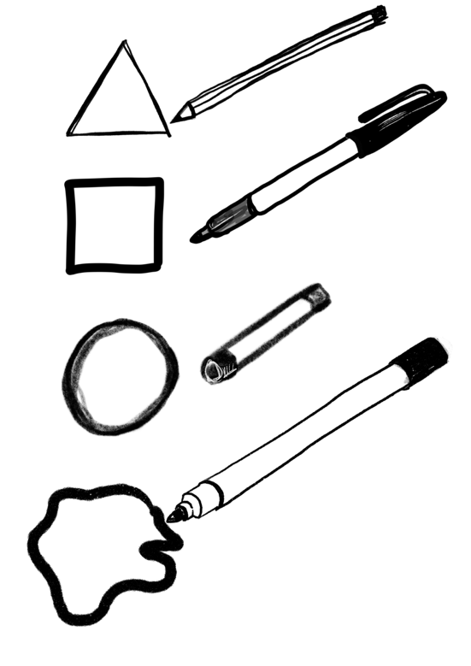
Image description: A black and white illustration featuring drawn shapes and drawing materials exploring positive and negative space.
Explore
Exploring and creating collage material

You need: recycled paper materials and/or paper, a pin or needle and scissors

First
Explore your home and check your recycling box. Collect any papers that have different textures.

Next
Take the papers you have found and try changing their surface.

Start with some easy techniques:
- Scrunching
- Folding

Try something different:
- Scoring and scraping with scissors or metal tools
- Fold the paper, snipping into the surface with scissors to make small incisions to lift up
- Making holes in the page – you can achieve this by using a soft surface like the foam included or a piece of fabric under your paper and puncturing the paper with a needle or pin. Try doing this sparsely (make marks far apart) and densely (make marks close together). Try experimenting with using both the front and back of the paper.

Last
Look at the paper materials you have gathered, they may already have pre-cut positive or negative spaces.

Why not layer up your materials. Cut shapes out of or into your new paper or use existing cut out shapes in your recycled paper materials to explore layering.

Experiment with light – use overhead light to play with your shapes and materials to explore the shadows they make.
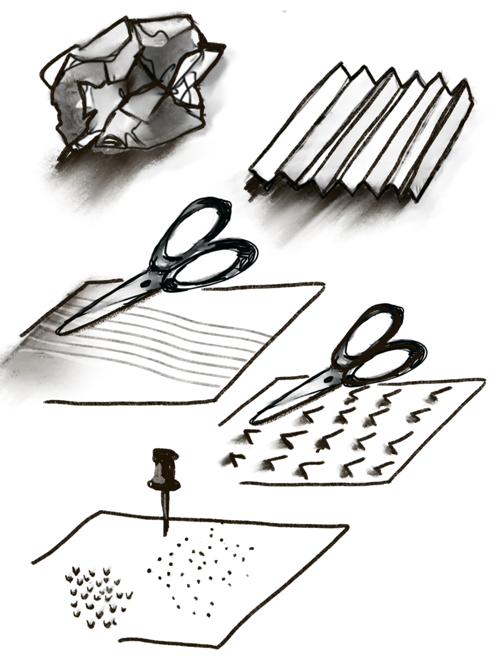
Image 6
Image description: A black and white illustration featuring different ways to create texture with paper, using folding, and scissors for scoring and snipping, and pin holes.
Explore
Composition Guide

You need: paper and drawing materials

First
Take a piece of paper – you are going to explore dividing up a page to act as a guide and to explore positive and negative shapes.

Next
There are many ways to fold paper and it’s fun to experiment. For this exploration we are going to fold the paper to make a grid. I am using an A4 piece of paper and folding it twice both vertically and horizontally. If your paper is bigger you may want to add more folds.

- Fold your paper vertical twice; give each fold a good crease each time. This should give you 3 creased vertical lines.
- Unfold your paper and fold it horizontally twice: give each fold a good crease. This should give you 3 creased horizontal lines.

Last
You now have a 16-grid box composition guide. Take a drawing material, pick two rectangle boxes that are side by side.

Draw a circle, so it is half in one box and half in another.

In one box fill in half of the circle, and in the other box fill in the space around the half circle.

Keep exploring using different shapes.

If you would like to create raised outline shapes try using the waxed string, Blu Tack, or the foam shapes.
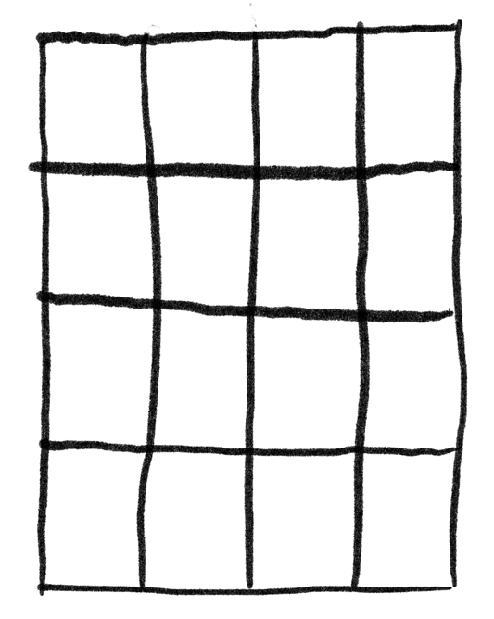
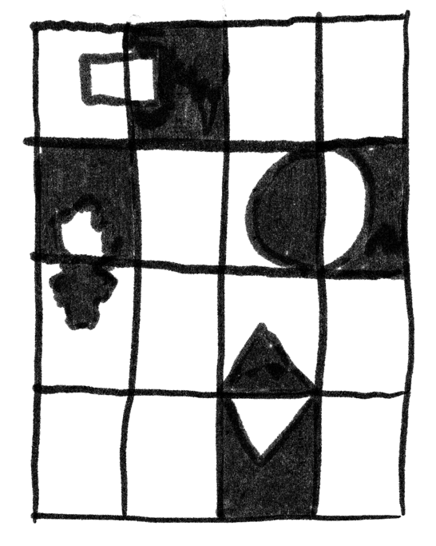
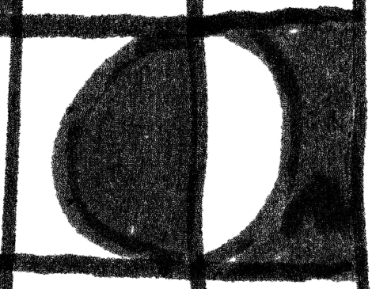
Image 7
Image description: A black and white illustration featuring a drawing
of a blank 16-grid box, a zoomed in example of a circle in a box, and
an illustration of a completed grid drawing using positive and negative space.
Develop
Stencils and Wax Resists

You need: thick paper, scissors, wax crayon, paint, and
drawing materials

First
Now you have explored using positive and negative space, we are going to make a simple stencil.

Take your thick paper and scissors. Fold the paper in half and cut out a shape in the middle of the folded paper to make your stencils. You now have made 2 stencils.

Next
- You can use the positive shape and create negative space, by drawing or painting over your stencil shape.
- Try your second stencil, unfold the paper. Lay the stencil flat on your paper, go over the cut-out negative space with drawing or painting material. Lift to reveal a positive shape on your paper.
- You can use tape or Blu Tack to hold your stencils down.

Last
Experiment with the stencil you have made – test it out using different materials. For example, you can use a waxy material to create a resist that you can paint over.

Try cutting different stencils – bigger or smaller, thicker, or thinner.

Take your experiments and stencils and layer them to create a collage.

Image 8
Image description: A black and white illustration of how to create paper stencils, using scissors, a wax crayon and a paintbrush.
Expand
Inspiration

You need: all the materials you have used so far and any more you would like to add

First
Think about what you have really enjoyed about this creativity kit?

How can you build on this?

- Materials – you have explored several different drawing and painting materials. Why don’t you go further and raid your kitchen or bathroom cupboards and your recycling bin. Spices, teas and coffees, oils, toothpaste? What could work as a resistant on the paper? What could act as paint?
- Why not add raised layers of positive and negative space with card, fabric, or other recycled materials?
- Go 3D – take some of the papers or stencil you have made and make sculpture out of them joining them with tape, glue or Blu Tack.

Next
Make a plan – we have been using first-next-last planning model for this kit. It’s a great way to get started but remember plans can also change as you go along.

Last
If there is a particular type of art you enjoy, try applying these techniques. For example, you could create a layered landscape, or an abstract 3D sculpture.

How to share your work

When you have made your artworks, we’d love to
include them on our community engagement blog.

Share your creations by emailing images to
learning@edinburghartfestival.com

or by sharing on social media and tagging
@EdArtFest

You can look for ideas and inspiration at
edartfestcommunityengagement.com

Drawing: Explore and Expand – Home Creativity Kit was devised by Louise K Fraser and shaped through consultation and contribution from artists who are visually impaired, Kasia Jakimczuk, Anne Dignan, Alan McIntyre, Alex Maxtone-Graham and Steve Oliver, who participate in Edinburgh Art Festival's Visual Description Programme.

DIY Art is a series of activity packs from Edinburgh Art Festival and selected artists, inviting you to get creative at home. The instructional creativity kits give insight into an artists' practice, showing how you can use their processes and techniques to create your own unique artwork.

Edinburgh Art Festival is the UK’s largest annual festival of visual art. Founded in 2004, we work with local and international partners to present an ambitious and meaningful programme of exhibitions, events and projects across the city. Since its beginnings, the festival has featured exhibitions including international and UK artists at a pivotal point in their career alongside the best emerging talent, major survey exhibitions of historic figures, and a programme of newly commissioned artworks that respond to historic sites in the city.

The festival’s year-round community engagement programme has long-term relationships and partnerships across the city, creating relevant and memorable experiences with artists. We invite local people to explore culture, community, the city, self-expression, and value, with many festival projects reflecting this unique creative relationship.

​Louise K Fraser is a neurodivergent teaching artist and educator

based in Edinburgh. She works across Scotland collaborating, co-creating, devising and delivering imaginative and original participatory workshops. As well as delivering Career-long Professional Learning, she also devises resources for galleries and local government authorities.

She continues to develop her own art practice, concentrating on drawing and printmaking from her studio in Leith, Edinburgh, while pursuing personal projects such as Teach Art, a residency programme and BRIDGE (Bridging The Pedagogical Gap), a research programme for artist educators. louise-k-fraser.com

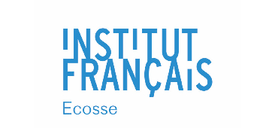
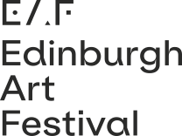
Special thanks to Institut français d’Écosse.

